|  |  |
| --- | --- |
| SoftPLC Manual | |
| Automation Competence Center | |
|  |  |

|  |  |
| --- | --- |
| Publication type: | SoftPLC Manual |
| Publication number: | ACC |
| Title: | SoftPLC Manual |
| Subject: | Automation Competence Center |
| Issue: | 1.4.18 |
| Publication date: | 7 February 2014 |
| Total number of pages: |  |
| Author: |  |
| Quality Control: |  |

Table of contents

Page #

2. Figures 3

3. Tables 4

4. References 6

5. Introduction 7

6. Safety instructions 9

7. Revision history 9

8. Softplc 10

8.1 Introduction 10

8.2 General 10

8.3 Basics 10

8.4 Simple example 11

8.5 Start 11

8.6 More functions 15

8.7 Extended 17

8.7.1 Example 1 18

8.7.2 Example 2 18

Figures

Figure 8‑1: Soft PLC 10

Figure 8‑2: SoftPLC Rename 11

Figure 8‑3: SoftPLC pop-up 12

Figure 8‑4: SoftPLC Assign Field 14

Figure 8‑5: SoftPLC first Line 14

Figure 8‑6: SoftPLC First Line_2 14

Figure 8‑7: General function block model 15

Figure 8‑8: the AND box 15

Figure 8‑9: Example 1 16

Figure 8‑10: Example 2 16

Figure 8‑11: Example 3 16

Figure 8‑12: Example 4 17

Figure 8‑13: Example 5 17

Figure 8‑14: Extended example 1 18

Figure 8‑15: Drop down box 18

Figure 8‑16: Add TON 19

Figure 8‑17: Add milliseconds 19

Tables

Table 8‑1: Add table 13

References

Not applicable.

Introduction

A Programmable Logic Controller, PLC or Programmable Controller is a digital computer used for automation of electromechanical processes, such as control of machinery on factory assembly lines, amusement rides, or light fixtures.

Unlike general-purpose computers, the PLC is designed for multiple inputs and output arrangements, extended temperature ranges, immunity to electrical noise, and resistance to vibration and impact. Programs to control machine operation are typically stored in battery-backed-up or non-volatile memory. A PLC is an example of a hard real time system since output results must be produced in response to input conditions within a limited time, otherwise unintended operation will result.

FT NavVision® integrated a PLC in the program itself to make it easier to implement programs for FT NavVision®.

Abbreviations list

OR Logic OR

XOR Exclusive OR

SELECT Select

TON Timer ON

TOF Timer OFF

TP Pulse Timer

R-TRIG Rising Trigger

F-TRIG Falling Trigger

MUL Multiply

DIV Divide

AD Add

SUB Subtract

LT Lesser Than

GT Greater Than

LE Lesser or equal

GE Greater or equal

EQ Equal

NE Not Equal

RS Reset before Set

SR Set before Reset

MAX Maximum

MIN Minimum

LIMIT Limit

CTU Up Counter

CTD Down Counter

CTUD Up-Down Counter

PULSE Pulse

Safety instructions

*:  
This section provides only a summary of the most important safety requirements and notes, which will be mentioned in the individual sections. To protect your health and prevent damage to the devices, it is essential to read and carefully follow the safety instructions.*

The indications NOTE, CAUTION and WARNING have the following significance:

*NOTE:  
An operating procedure, practice or condition etc., which it is essential to emphasize.*

**CAUTION**

**An operating procedure, practise or condition etc., which, if not strictly observed, may damage or destroy equipment.**

**WARNING**

**An operating procedure, practise or condition etc., which, if not carefully observed may result in personal injury or loss of life.**

Revision history

Revisions issued since publication.

|  |  |  |  |
| --- | --- | --- | --- |
| **Issue** | **Date** | **Revision** | **Reason** |
| 1.0 | January 31, 2013 |  | initial release |

# Softplc

## Introduction

As explained in the introduction the PLC is a programmable controller. It is used to make some logic controls that automate the operation and functionality of certain processes.

Normally this is programmed right into the PLC itself. The pro is that it can work stand alone. The con is that the programming of a PLC is time consuming and you need to know everything about the specific PLC. Especially when you need it to interact with FT NavVision© it becomes quit a hassle.

## General

A PLC (programmable logic controller) is an electronic device with a microprocessor that, on the basis of its various inputs, controls its outputs. A good example is the Wago PLC that we use often with our system. To make it easier to use and also to extend the range to use it with, we developed a soft PLC for FT NavVision® . It is way beyond the scope of this manual to teach you how to program a PLC. That is knowledge that you need to have or that you need to acquire. The functionality is the same as any other PLC programming device.

## Basics

When you open Soft PLC for the first time you get an empty screen (see Figure 8‑1)

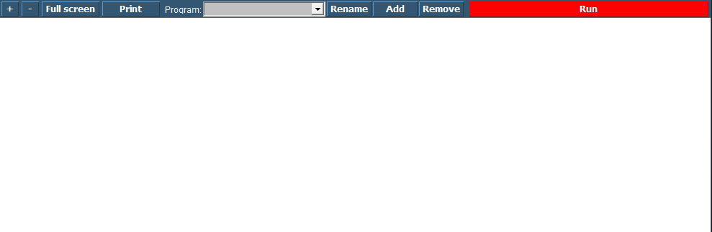

Figure 8‑1: Soft PLC

The following figures apply to the buttons on the screen:

|  |  |
| --- | --- |
| **Soft PLC Switch** | **Function** |
| +/- | Zoom in or out |
| Full Screen | Goto Fullscreen mode |
| Print | Print the Ladder Diagram |
| Program | Choose which PLC program you want to adjust by clicking the dropdown button |
| Rename | Rename the PLC program |
| Add | Add a new PLC program |
| Remove | Remove a PLC program |
| Run | Manually run or stop a specific PLC program |

## Simple example

Just to explain how it works, we will show a small example. This is merely to show how the diverse methods of implementing work in case you are already familiar with PLC programming.

## Start

When you click “Add” you will start a new program. This program starts with an empty line and is called “SoftPLC1” if it is the first program you start. If you click “Rename” you can give it a distinctive name, which will pay off when you have a lot of PLC programs in your system (see Figure 8‑2).

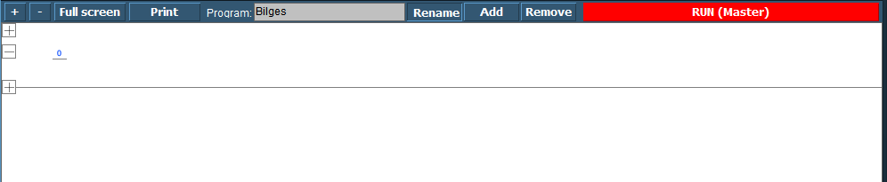

Figure 8‑2: SoftPLC Rename

Once you renamed it, you can go on with the program. For those familiar with PLC programming, you will recognize this as a ladder diagram. With the “+” you can add lines before or after and with “–“ you can remove the line.

We start this program with a bilge pump, which should run when a certain bilge alarm is high. When you click at the left side of the “0” a new pop-up appear with choices (see Figure 8‑3).

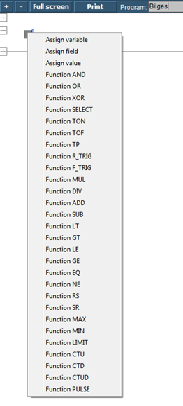

Figure 8‑3: SoftPLC pop-up

|  |  |
| --- | --- |
| Function | Explanation |
| Assign Variable | Assign a variable that you defined in the program |
| Assign Field | Assign a FT NavVision© field |
| Assign Value | Assign a value |
| Function OR | Logic OR |
| Function XOR | Exclusive OR |
| Function SELECT | Select |
| Function TON | Timer ON |
| Function TOF | Timer OFF |
| Function TP | Pulse Timer |
| Function R-TRIG | Rising Trigger |
| Function F-TRIG | Falling Trigger |
| Function MUL | Multiply |
| Function DIV | Divide |
| Function AD | Add |
| Function SUB | Subtract |
| Function LT | Lesser Than |
| Function GT | Greater Than |
| Function LE | Lesser or equal |
| Function GE | Greater or equal |
| Function EQ | Equal |
| Function NE | Not Equal |
| Function RS | Reset before Set |
| Function SR | Set before Reset |
| Function MAX | Maximum |
| Function MIN | Minimum |
| Function LIMIT | Limit |
| Function CTU | Up Counter |
| Function CTD | Down Counter |
| Function CTUD | Up-Down Counter |
| Function PULSE | Pulse |

Table 8‑1: Add table

We choose for “Assign Field” to assign the Bilge Alarm as a trigger (see Figure 8‑4). Now we get into the FT part of the SoftPLC. You’ll get the FT NavVision© field dialog box where you can choose the appropriate field (see Figure 8‑4). After choosing the field the PLC line will look as in Figure 8‑5

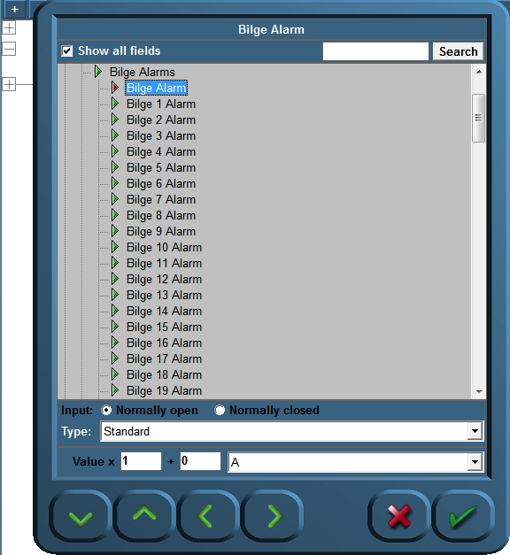

Figure 8‑4: SoftPLC Assign Field

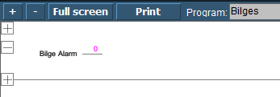

Figure 8‑5: SoftPLC first Line

We do the same at the right side of the “0” but this time we choose the Bilge Pump. We end up with a line like in Figure 8‑6.

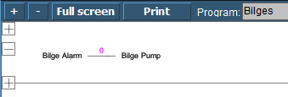

Figure 8‑6: SoftPLC First Line_2

So now when you press “Run” the program will run and check the bilge alarm over and over. Once it gets high, the connection in the line gets high (1) and the Bilge Pump starts running until the alarm is not high anymore.

## More functions

If you are familiar with PLC programming, you’ll know that it is mostly about function blocks.

A generalized function block consists of input variables, output variables, through variables, internal variables, and an internal behavior description of the function block. Input variables can only be written from outside of an FB. From inside they can only be read. Output variables can be read and written from inside of an FB and only be read from outside. Through variables are special shared variables. If through variables of different FB instances are connected, they do all access the variable connected to the first input of the chain. Through variables are defined in [IEC 61131]. They are often called In-Out-variables. If their datatype matches, output variables can be connected to input variables by a connector. This is similar to a connection of ports with matching protocols.

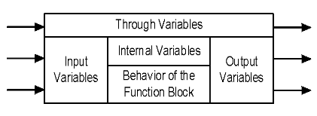

Figure 8‑7: General function block model

In Table 8‑1 you can see which function blocks are declared in FT NavVision® these are the most commonly used.

If, for example, you want to make a program with a set and reset and different variables, it can go like the following.

Click on the left side of the 0 and choose “Function AND”. A function block with the AND denominator will appear (see Figure 8‑8). Now you can define the fields or variables that need to be true (all) to make the AND box work. In the example we use two denominators. So we need to assign two fields to the left side of the box.

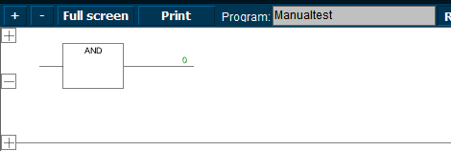

Figure 8‑8: the AND box

First click at the left side of the line and choose “Assign field”. We choose an expansion tank overload (see Figure 8‑9). Now we want the pump (that we implement later) to start only as both SB and PS expansion are at overload. We need to add the other tank in front of the ADD-box. Click at the bottom left and choose “Assign field” and add the other tank (see Figure 8‑10).

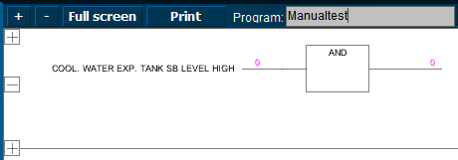

Figure 8‑9: Example 1

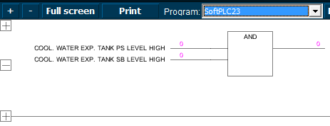

Figure 8‑10: Example 2

Now we want the pump we are going to add to be started as both fields are true (1). But we cannot only set the pump, we also need to reset it. So at the right side after the “0” we will put a set/reset box. Click and choose “Function SR” you’ll get a set/reset box (see Figure 8‑11).

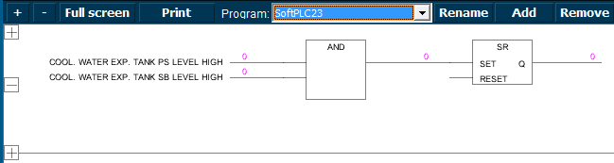

Figure 8‑11: Example 3

Now we have the SET-side ready. If both tanks get a high alarm (1) it will get high on the set/reset box which will set the other side of the box. Here we can put the field for the desired pump so that pump will start as the box is set. Click all the way right and choose “Assign field” and choose the appropriate field. It will look like the following figure:

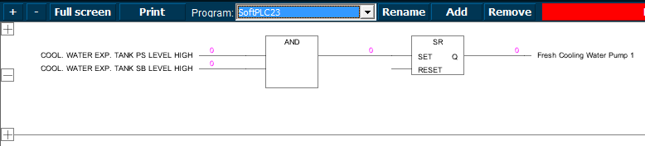

Figure 8‑12: Example 4

So, the SET is made. The pump will run once the conditions are met. However we do want to reset the pump as well. In the Set/Reset-box you see a reset entrance. Click here and choose “Function AND” or “Function OR” whichever you want to use. We will use the AND-function for this example. You will get a new “AND” box which we will connect to the same fields as we did in the first box. Except this time we will negate them. This means that the conditions are met if the field is NOT high (1) or in this case they must be low (0) to meet the conditions. You can negate these fields by clicking your mouse at the line near the box. A circle will appear (see Figure 8‑13).

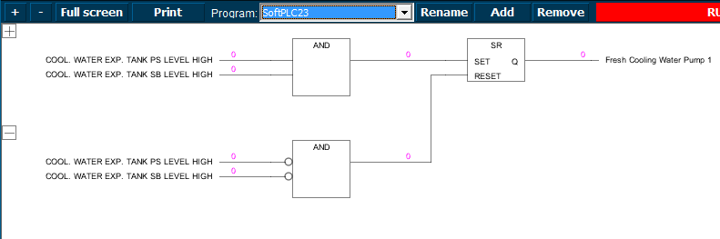

Figure 8‑13: Example 5

Conclusion: this program makes the “Fresh cooling water pump” run as both tank level alarms gets high. This will remain so until both tank level alarms are out of alarm after which the switch will reset the pump.

## Extended

Of course you can extend this program as far as you wish, but that Is beyond the scope of this manual. This manual is merely to show you how to work with the SoftPLC. Just as a reference we will show you some more examples to get familiarized with the program.

### Example 1

The example we used in paragraph 8.6 is a little bit straight forward. It is just on and of switching of a pump depending on the state of a couple of level switches. Now we can change that to make it more accurate by, for example reset the pump when either of the alarms goes out of alarm (see Figure 8‑14). This is easily changed by clicking on the box. A drop-down menu appears where you can choose all the functions (see Figure 8‑15).

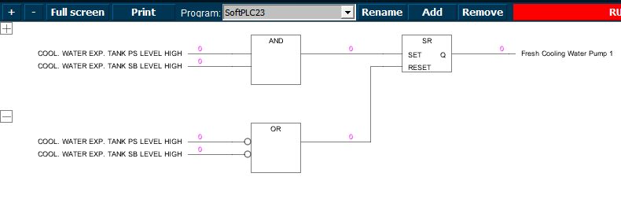

Figure 8‑14: Extended example 1

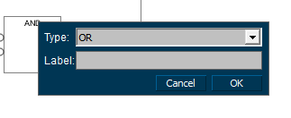

Figure 8‑15: Drop down box

You can even give the function blocks a label. Just to keep it synoptic in bigger programs.

### Example 2

In example 1 we changed AND to OR. So now the pump will be rest if one of the level alarms will get low (0). You can imagine that you want the pump to run a little longer, just to empty a little bit more out of the tanks. This can be done by adding a timer between the OR-box and the reset.

Click at the height of the “0” at the right side of the OR-box. Choose “Function TON” A timer box will appear (see Figure 8‑16). Now you can set a time (in milliseconds) that the OR-function will hold until it will give the function to the reset. If you like the function to wait for 10 seconds then you click the line before PT and choose “Assign value”. A box will appear. Type 10000 (for milliseconds which is 10 seconds) and choose OK (see Figure 8‑17). Now the timer will wait 10 seconds before it will trigger the reset.

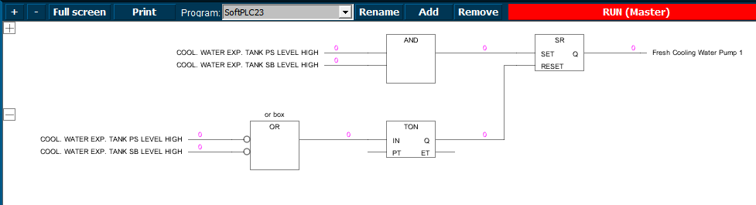

Figure 8‑16: Add TON

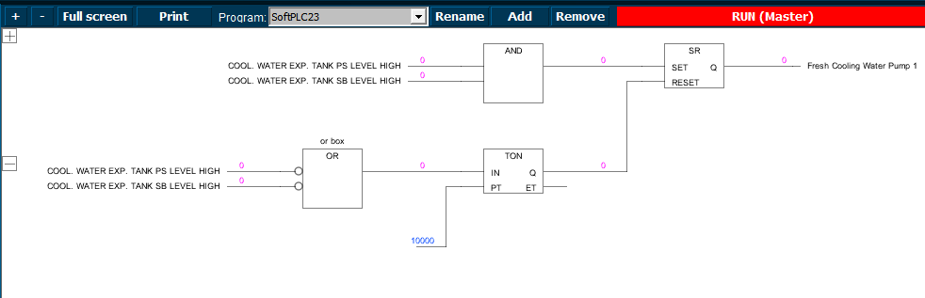

Figure 8‑17: Add milliseconds

*: to remove a particular box, value or field, just hover your mouse over it and press “Delete”.*

Free Technics

Technical & customer support **The Netherlands**

Free Technics B.V.

Eikenlaan 259J

2404 BP, Alphen aan den Rijn

The Netherlands

Telephone: +31 172418 890

Fax: +31 172418 899

www.freetechnics.eu